|  |
| --- |
| 1. **Format:**   • follows an agreed format/layout  • similar enough to the agreed format  • different to the agreed format |
| 1. **Specific to project**   • links clearly and well to the team’s project  • report fits well within the project  • unclear link to the project |
| 1. **Agreed topic:**   • report on agreed topic  • different topic than agreed |
| 1. **Independent work:**   • report clearly developed independently  • mostly developed independently  • relies heavily on found information |
| 1. **Within page limit:**   • one-page report  • more or less than a page  • well over or well under the limit |
| 1. **Benefit of report:**   • very useful: excellent analysis, relevant to to project, reduces research and development time for whole team  • somewhat useful: relevant to only some of the team or some development work  • not useful or generic information |
| 1. **Contribution to quality:**   • provides clear guidelines on quality of code contributions  • some relevant quality of code contributions  • not useful information on quality contribution |
| 1. **Justification of tech stack move/changes:**   • meets or is possible to meet all requirements of “Choosing a different tech stack”  • meets most requirements for “Choosing a different tech stack”  • meets only some requirements for “Choosing a different tech stack”  • does not meet requirements for “Choosing a different tech stack” |

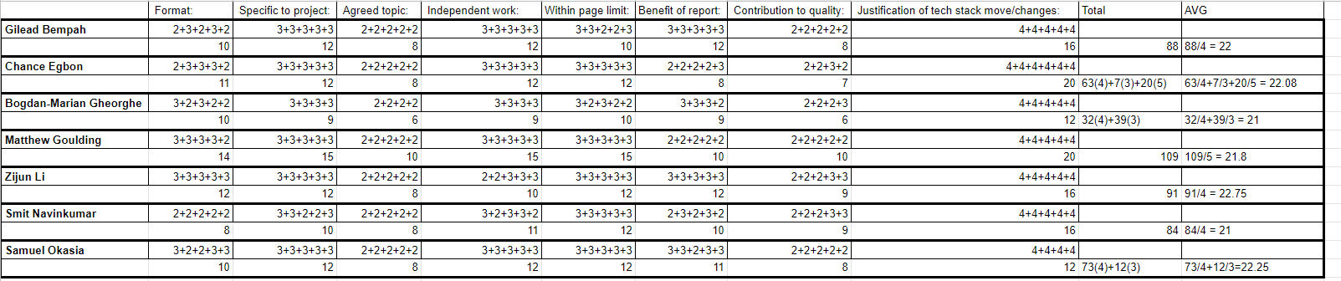

The DevOps Tech Report has a title section, an introduction, a body and a conclusion meaning that it follows the agreed format of a report.

The reports talk about a way of creating software that prioritises, IT operations professionals and software developers, cooperation and communication. It also touches on how the development and deployment of a program can be guided by automating and integrating the workflow and tools of the individuals involved and how we are making use of GitHub and Amazon EC2 virtual machine to facilitate collaborative working and “code integration”.

The report is on the agreed topic assigned to Matthew, it is of one page and it is clear that Matthew developed the report independently.

The report is somewhat useful as it is quite general.

although the report talks about some tools it misses quality code contribution.

**Diary MVP Current status.**

Currently, the Diary MVP only store the unfished HTML file of the Diary feature. The MVP only holds the frontend of the Diary feature as no backend has been implemented yet. At this stage, HTML and CSS have been used to create the visual aspect of the navigation system of the Diary webpage.

The navigation menu will be used by the user to navigate through the web application and make use of the various available features. Since not all the features have been fully developed the links are void and The page looks shallow because the page's main contents are still being developed.

**Diary MVP Goal status.**

The final status of the Diary MVP should reflect the initial design that was submitted in the first Assignment. The MVP should hold the full stack of the Diary feature, this should include the backend and the frontend of the Diary webpage.

The frontend should provide a way for the user to interact with the system and make use of the diary feature. It should allow the user to navigate through the web application, create and delete events by adding or deleting to the to-do list, write records related to items in the to-do list, and navigate through the scheduler to find and view other daily records. The feature’s interface should be well-detailed, all text should be easy to read and understand, all visible elements should be well-spaced, it should have a good colour scheme and it should be similar to the initial design.

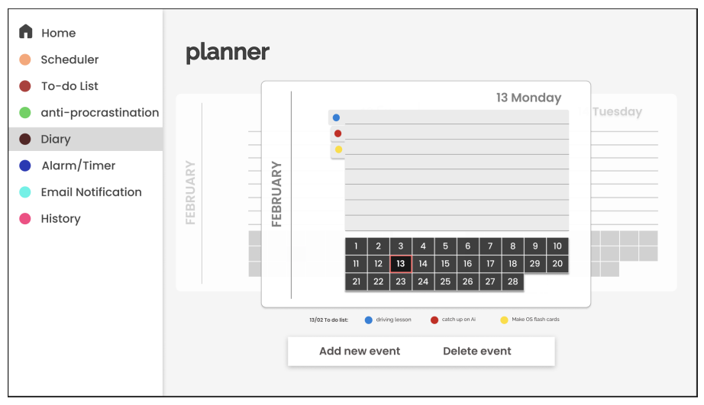

The backend should provide a way to store, edit and delete information. It should help create a relationship between the Diary features and the scheduler and the to-do list feature. It should allow the user to indirectly make use of the database. When the add new event is clicked a new to-do list item should be created in the to-do table, when the delete even button is clicked a specific item should be deleted from the to-do table.

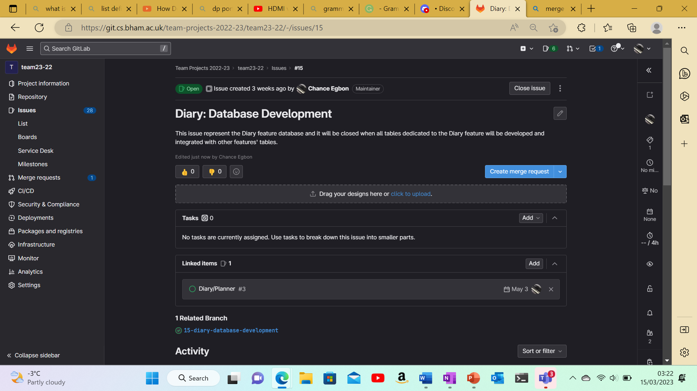

**Chance Egbon**